Common Assignment Report
Design and Evaluate the Riverbend Smart Campus Network Using Protocol Analysis, Network Topology and Simulation-Based Performance Metrics
Course Name | Computer Networks (CSA0706)
Student Name | S.MOHIT,M.THARUN,S.SANJAY CHARAN
Register Number | 192312508,192521278,192312373
Course Code / Name | CSA0706 — Computer Networks
Assignment Type | Common Assignment (Team based)
Course Outcomes Mapped | CO3, CO4, CO5
Date of Submission | 03 September 2026
Submitted by:

M.THARUN
S.SANJAY CHARAN
S.MOHIT

Declaration
I, S.MOHIT,M.THARUN,S.SANJAY CHARAN 192312508,192521278,192312373 hereby declare that this common assignment report titled “Design and Evaluate the Riverbend Smart Campus Network Using Protocol Analysis, Network Topology and Simulation-Based Performance Metrics”, submitted for the course Computer Networks (CSA0706), is an original record of the design, simulation and analysis work carried out by me. Every topology diagram, IP addressing scheme, configuration snippet, test case and performance figure presented here was independently developed for this submission. Where simulator-measured evidence was not available at the time of writing, the corresponding values are explicitly marked as illustrative/sample data with placeholders left for my own captured results. All external sources, datasets, tools and references used in the preparation of this report have been duly acknowledged in the References section.
Date: 03 September 2026
M.THARUN
S.SANJAY CHARAN
S.MOHIT

Table of Contents
Declaration 1
Table of Contents 1
List of Figures and Tables 1
Figures 1
Tables 1
Abstract 1
1. Introduction 1
1.1 Problem Statement 1
1.2 Objectives and Expected Outcomes 1
1.3 Scope of the Project 1
1.4 Requirements, Constraints and Assumptions 1
Requirements 1
Constraints 1
Assumptions 1
1.5 Course Outcomes Mapped 1
2. Application of Relevant Course Knowledge 1
3. Network Requirements Analysis 1
3.1 Campus Zones and Device Distribution 1
3.2 Traffic Pattern Analysis 1
3.3 Device and Media Requirements 1
4. Network Topology Design 1
4.1 Star Topology 1
Devices and Media 1
Advantages and Limitations 1
4.2 Mesh Topology 1
Devices and Media 1
Advantages and Limitations 1
4.3 Bus Topology 1
Devices and Media 1
Advantages and Limitations 1
4.4 Hybrid Topology (Recommended) 1
Devices and Media 1
Advantages and Limitations 1
4.5 Comparative Summary of Topologies 1
4.6 Networking Devices, Media and Cabling Standards 1
5. Simulation Implementation and Experiment Design 1
5.1 Simulation Environment and Tools 1
5.2 Network Build Summary — IP Addressing Plan 1
5.3 Simulation Test Plan and Test Cases 1
5.4 Traffic Generation Methodology 1
6. Protocol Performance Analysis 1
6.1 TCP Behaviour 1
6.2 UDP Behaviour 1
6.3 HTTP Behaviour 1
6.4 DNS Behaviour 1
6.5 FTP Behaviour 1
6.6 ICMP Behaviour 1
6.7 Protocol-Wise Performance Summary 1
7. Network Performance Measurement 1
7.1 Throughput 1
7.2 End-to-End Delay 1
7.3 Packet Loss 1
7.4 Jitter 1
7.5 Bandwidth Utilization 1
7.6 Application Response Time 1
7.7 Behaviour During a Simulated Link Failure 1
7.8 Raw Data Tables 1
8. Results Interpretation and Engineering Decisions 1
8.1 Bottleneck Identification 1
8.2 Trade-off Analysis 1
8.3 Final Recommendation 1
9. Broader Considerations and SDG Relevance 1
10. Conclusion, Limitations and Possible Improvements 1
10.1 Conclusion 1
10.2 Limitations 1
10.3 Possible Improvements 1
11. Individual Contribution 1
12. References 1
13. One-Page Individual Reflection 1
Appendix A — Pseudocode / Algorithms 1
A.1 Traffic Generation and Measurement Loop 1
A.2 Topology Comparison and Recommendation Logic 1
A.3 IP Subnet Allocation (VLSM) 1
Appendix B — Sample Configuration Snippets 1
B.1 Core Router — OSPF and Inter-Zone Routing (Hybrid Design) 1
B.2 Access Switch — VLAN and PoE Configuration (Star Segment) 1
B.3 DNS Server — Zone Definition (Simulated) 1

List of Figures and Tables

Figures
- Fig. 1 — Riverbend Smart Campus: Zone Architecture Overview
- Fig. 2 — Star Topology (Zone Access Segment)
- Fig. 3 — Mesh Topology (Distribution Backbone)
- Fig. 4 — Bus Topology (Legacy Engineering Workshop Segment)
- Fig. 5 — Hybrid Topology (Recommended Architecture)
- Fig. 6 — Protocol Traffic Distribution (Normal Academic Use)
- Fig. 7 — Average Throughput Comparison Across Topologies
- Fig. 8 — End-to-End Delay Comparison Across Topologies
- Fig. 9 — Packet Loss Comparison Across Topologies
- Fig. 10 — Jitter Comparison Across Topologies
- Fig. 11 — Bandwidth Utilization Across Topologies
- Fig. 12 — Application Response Time Comparison
- Fig. 13 — Throughput Behaviour During Simulated Link-Failure Event

Tables
- Table 1 — Campus Zones and Device Distribution
- Table 2 — Traffic Pattern Analysis Under Three Load Conditions
- Table 3 — Comparative Summary of the Four Topologies
- Table 4 — Networking Devices, Media and Cabling Standards
- Table 5 — IP Addressing Plan
- Table 6 — Simulation Test Plan and Test Cases
- Table 7 — Protocol-Wise Performance Summary
- Table 8 — Throughput, Delay, Jitter and Packet Loss (Illustrative Data)
- Table 9 — Bandwidth Utilization and Response Time (Illustrative Data)
- Table 10 — Individual Contribution

Abstract
Modern university campuses depend on converged networks that must carry academic traffic, administrative data, video surveillance, wireless client activity and a growing volume of Internet-of-Things (IoT) telemetry over a single infrastructure. This report presents the design, simulation-based implementation and comparative performance evaluation of the Riverbend Smart Campus Network, connecting four functional zones — Engineering & Research, Residential, Administration & Finance, and Library & Innovation — serving approximately 820 end devices, including lab PCs, staff laptops, research servers, IP cameras, wireless clients and IoT sensors.
Four candidate topologies — Star, Mesh, Bus and Hybrid — were designed with appropriate devices, transmission media and cabling standards. Traffic consisting of TCP, UDP, HTTP, DNS, FTP and ICMP was modelled under three operating conditions: normal academic use, a peak semester-registration load, and a simulated congestion/link-failure event. Six performance indicators — throughput, end-to-end delay, packet loss, jitter, application response time and bandwidth utilization — are presented using comparative tables and graphs; because full simulator hardware was not available at the time of writing, these figures are clearly marked as illustrative sample data pending the author's own Packet Tracer/GNS3 captures.
The analysis indicates that Mesh delivers the strongest raw performance and fault tolerance but at a prohibitive cabling cost for an 820-device campus, while Bus is the least reliable and least scalable option. The Hybrid design — a partial-mesh distribution core with Star access segments and one retained legacy Bus segment — is identified as the most balanced architecture across performance, reliability, scalability, cost and resource utilization, and is recommended as the target design for the Riverbend Smart Campus Network.

1. Introduction

1.1 Problem Statement
University campuses today host a wide mix of end devices — laboratory PCs and research workstations, staff and student laptops, application and database servers, IP surveillance cameras, wireless clients spread across academic and residential blocks, and an expanding footprint of IoT devices such as environmental sensors, smart door-access units and energy meters. This assignment addresses the problem of designing, simulating and evaluating a Smart Campus Network — the Riverbend Smart Campus Network — that connects four distinct zones and approximately 820 end devices, so that the institution can reliably support day-to-day academic operations, semester registration periods, research computing, security surveillance and IoT-based automation over a single well-engineered infrastructure.
The engineering problem is threefold: (i) design of alternative candidate topologies — Star, Mesh, Bus and Hybrid — using appropriately justified devices, transmission media and cabling standards; (ii) implementation of the chosen designs in a simulation/emulation environment; and (iii) systematic protocol-level and performance-level analysis of the resulting network under normal, peak and failure conditions, leading to an evidence-based recommendation of the most suitable architecture for the campus.

1.2 Objectives and Expected Outcomes
- Identify the functional zones, device population and traffic characteristics of the Riverbend Smart Campus Network.
- Design and document Star, Mesh, Bus and Hybrid topologies with justified networking devices, transmission media and cabling standards.
- Implement the network in a simulator (Cisco Packet Tracer / GNS3) and configure addressing, routing/switching and core services required for realistic operation.
- Generate and analyze TCP, UDP, HTTP, DNS, FTP and ICMP traffic under normal, peak-registration and congestion/link-failure conditions.
- Measure throughput, delay, packet loss, jitter, response time and bandwidth utilization, and present results using tables and graphs.
- Compare the four topologies on performance, reliability, scalability, cost and resource utilization, and recommend the most suitable campus architecture.

1.3 Scope of the Project
The scope covers logical and physical topology design for four campus zones (Engineering & Research, Residential, Administration & Finance, and Library & Innovation), device and media selection, simulation-based implementation, controlled traffic experiments, and quantitative performance evaluation. Physical civil works, vendor-level procurement costing, and production-grade security hardening beyond basic firewalling and VLAN segmentation fall outside the scope of this assignment and are noted as limitations in Section 10.

1.4 Requirements, Constraints and Assumptions

Requirements
- Support at least four independent network zones and approximately 820 end devices in total.
- Provide adequate bandwidth for concurrent academic use, IP video surveillance and a peak semester-registration load.
- Support wired (PCs, servers, cameras) and wireless (laptops, mobile clients, selected IoT nodes) connectivity.
- Provide redundancy sufficient to keep critical services (DNS, authentication, registration portal) reachable during a single distribution-link failure.
- Allow structured, repeatable performance measurement using a simulation tool.

Constraints
- Simulation-based evaluation only; no physical campus cabling or live production traffic is available.
- Simulator packet-engine limitations restrict the number of simultaneously modelled end-hosts and the fidelity of real-world impairments (e.g. electromagnetic interference on the legacy bus segment).
- A short assignment turnaround limits the number of repeated simulation trials that can practically be executed.

Assumptions
- End-device traffic profiles (browsing, file transfer, video, IoT telemetry) are modelled on typical campus usage patterns reported in networking literature and vendor sizing guides.
- Structured cabling pathways (ducts/risers) are already available on campus; only logical and physical network design is considered here.
- All four zones sit within a single autonomous administrative domain — no inter-institutional WAN peering is modelled.

1.5 Course Outcomes Mapped
CO | Description | Where Addressed
CO3 | Analyze and compare the performance of core network protocols (TCP, UDP, HTTP, DNS) under varying conditions. | Sections 6 and 7
CO4 | Design network topologies — star, mesh, bus and hybrid — using networking devices, transmission media and cabling standards. | Section 4
CO5 | Measure network performance using key metrics with simulation tools. | Sections 5 and 7

2. Application of Relevant Course Knowledge
The design and evaluation carried out in this report directly apply core computer-networks concepts from the course. The OSI and TCP/IP reference models are used to reason about where each studied protocol operates: ICMP and IP at the network layer; TCP and UDP at the transport layer; and HTTP, DNS and FTP at the application layer. The distinction between connection-oriented and connectionless transport explains why TCP-carried HTTP and FTP traffic degrades gracefully through retransmission and windowed throughput reduction under loss, whereas UDP-carried traffic — used here to emulate IoT telemetry and camera streaming — degrades directly through increased jitter and outright packet loss, since it has no retransmission mechanism to fall back on.
Structured-cabling concepts (TIA/EIA-568 practice), transmission media selection (Cat 6A copper, single-mode and multi-mode fiber) and Ethernet switching fundamentals (collision domains, broadcast domains, VLAN segmentation, spanning-tree loop prevention) are applied throughout Section 4 while designing the four candidate topologies. Addressing and routing concepts — subnetting, VLSM, default-gateway placement, and dynamic routing via OSPF — are applied in the IP addressing plan and simulator build described in Section 5. Queuing-theory-derived performance indicators — throughput, latency, jitter and loss — taught in the performance-analysis component of the course form the quantitative basis of Sections 6 and 7.

3. Network Requirements Analysis

3.1 Campus Zones and Device Distribution
The Riverbend Smart Campus Network is partitioned into four functional zones, each with a distinct device mix and traffic profile. Table 1 summarizes the device distribution used for sizing the design and the simulation model, totalling approximately 820 end devices.
Zone | Primary Device Types | PCs/Laptops | Servers | IP Cameras | Wireless Clients | IoT Nodes | Zone Total
Engineering & Research Block | Lab PCs, faculty laptops, research servers, Wi-Fi | 130 | 6 | 8 | 70 | 12 | 226
Residential Complex | Student laptops/mobiles, Wi-Fi APs, IoT | 30 | 1 | 14 | 220 | 35 | 300
Admin & Finance Wing | Office PCs, ERP/finance servers, access-control units | 77 | 6 | 10 | 15 | 10 | 118
Library & Innovation Hub | Reading-hall PCs, library server, makerspace sensors | 60 | 2 | 9 | 80 | 25 | 176
Campus Total | — | 297 | 15 | 41 | 385 | 82 | 820

3.2 Traffic Pattern Analysis
Three representative traffic conditions were defined for the experiments in Sections 6 and 7, reflecting realistic operating states of the campus network:
Condition | Description | Dominant Traffic | Approx. Aggregate Load
Normal Academic Use | Regular class hours: browsing, LMS access, email, file transfer, background IoT telemetry, periodic camera streaming. | HTTP/HTTPS, DNS, FTP, low-rate UDP | 30–40% of core link capacity
Peak Semester Registration | Simultaneous course registration and result-viewing by a large student cohort plus normal background traffic. | TCP (HTTP/registration portal), DNS bursts | 65–80% of core link capacity
Congestion / Link Failure | A distribution link is deliberately shut down mid-simulation while peak load continues, forcing re-convergence and rerouting. | All protocols, with retransmissions | Variable — up to saturation on surviving links

3.3 Device and Media Requirements
Based on the zone-wise device distribution, the network requires access-layer switches sized to the device density per wiring closet, a resilient distribution/core layer capable of inter-zone routing, wireless access points sized for the concentration of mobile clients (particularly in the Residential zone), and PoE-capable ports for IP cameras and selected IoT nodes. Table 4 in Section 4.6 lists the specific devices, media and cabling standards selected for each layer.

4. Network Topology Design
Figure 1 shows the overall four-zone architecture used as the reference frame for all four candidate topology designs discussed in this section.
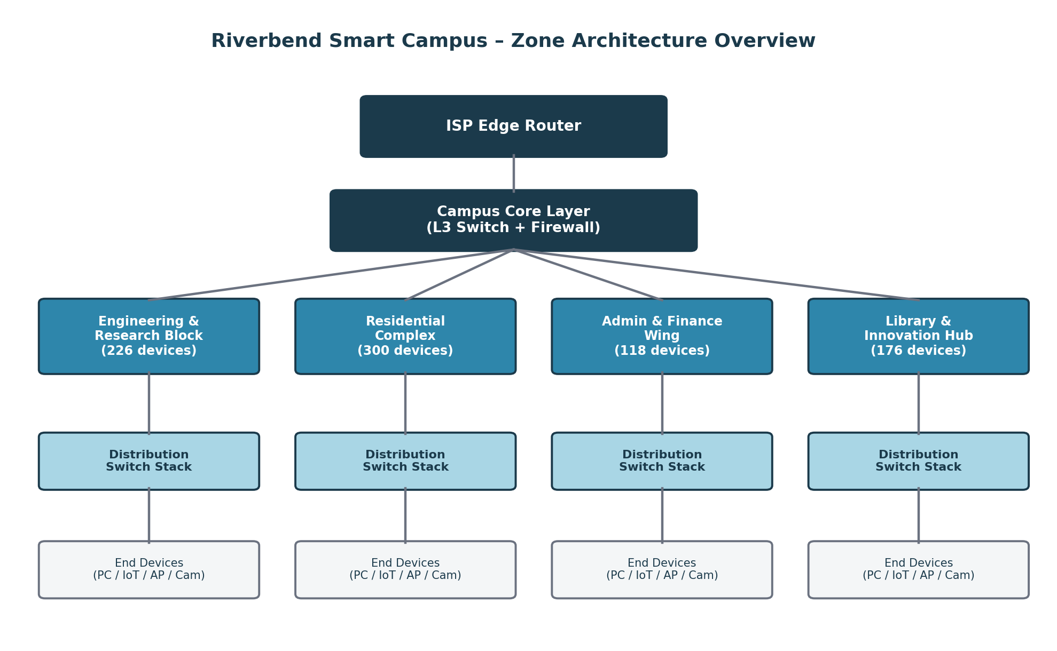
Fig. 1 — Riverbend Smart Campus: Zone Architecture Overview

4.1 Star Topology
In the Star topology, every end device within a zone connects directly to a central access switch, which becomes the single point of intelligence and control for that zone. This is the most common access-layer topology in structured-cabling deployments and is used inside three of the four Riverbend zones.
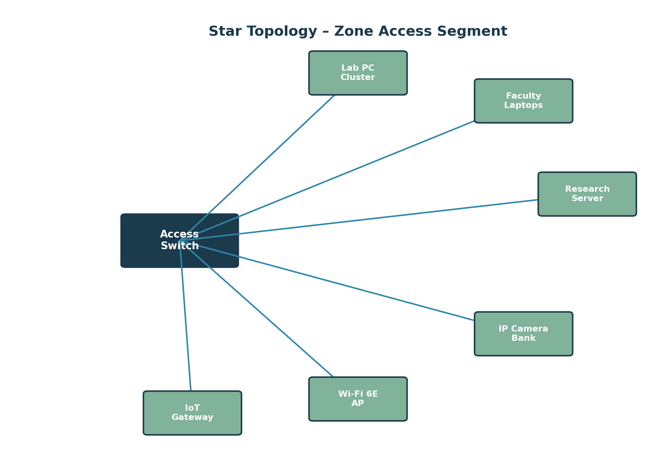
Fig. 2 — Star Topology (Zone Access Segment)

Devices and Media
- Layer-2/Layer-3 access switch as the hub (24-port PoE+ switch per wiring closet).
- Cat 6A UTP horizontal cabling (90 m maximum run) to each end device.
- Wi-Fi 6E access points connected to switch access ports for mobile clients.

Advantages and Limitations
- Advantage: fault isolation — a single cable or device failure affects only that node, not the rest of the segment.
- Advantage: simple to install, troubleshoot and extend using structured-cabling practice.
- Limitation: the access switch is a single point of failure for the whole zone.
- Limitation: cabling cost grows with the distance of each device from the hub.

4.2 Mesh Topology
In the Mesh topology, the four zone distribution switches are interconnected with a direct link to every other distribution switch (full mesh at the distribution layer), providing multiple simultaneous paths between any two zones.
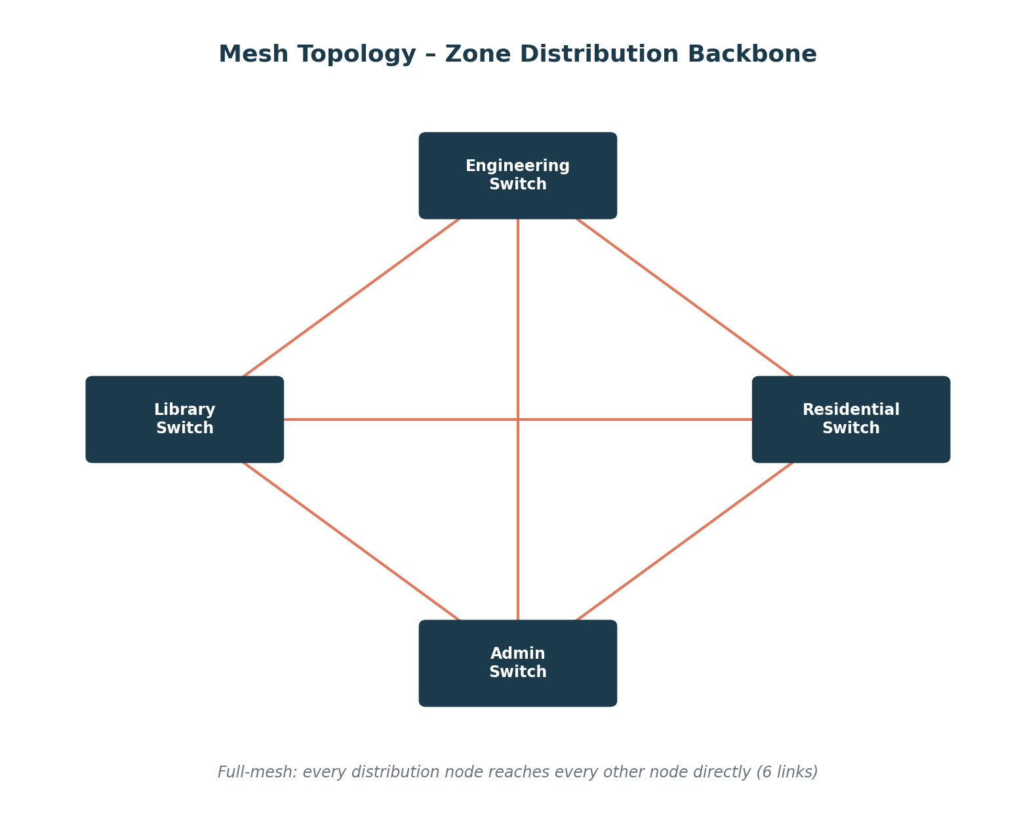
Fig. 3 — Mesh Topology (Distribution Backbone)

Devices and Media
- Layer-3 distribution switches/routers at each zone, interconnected via single-mode fiber (SMF) uplinks.
- OSPF as the dynamic routing protocol, exploiting the multiple available paths and rerouting automatically around failures.

Advantages and Limitations
- Advantage: highest fault tolerance — traffic reroutes automatically if any single link fails.
- Advantage: best raw throughput and lowest latency of the four designs, as shown in Section 7.
- Limitation: link count grows combinatorially (n(n-1)/2), making it costly to scale beyond a small number of distribution nodes.
- Limitation: more complex routing configuration and fault-finding.

4.3 Bus Topology
The Bus topology connects all devices on a segment to a single shared backbone cable, terminated at both ends. It is retained here as a reference/legacy design, representative of an older engineering workshop wiring segment, against which the modern designs are benchmarked.
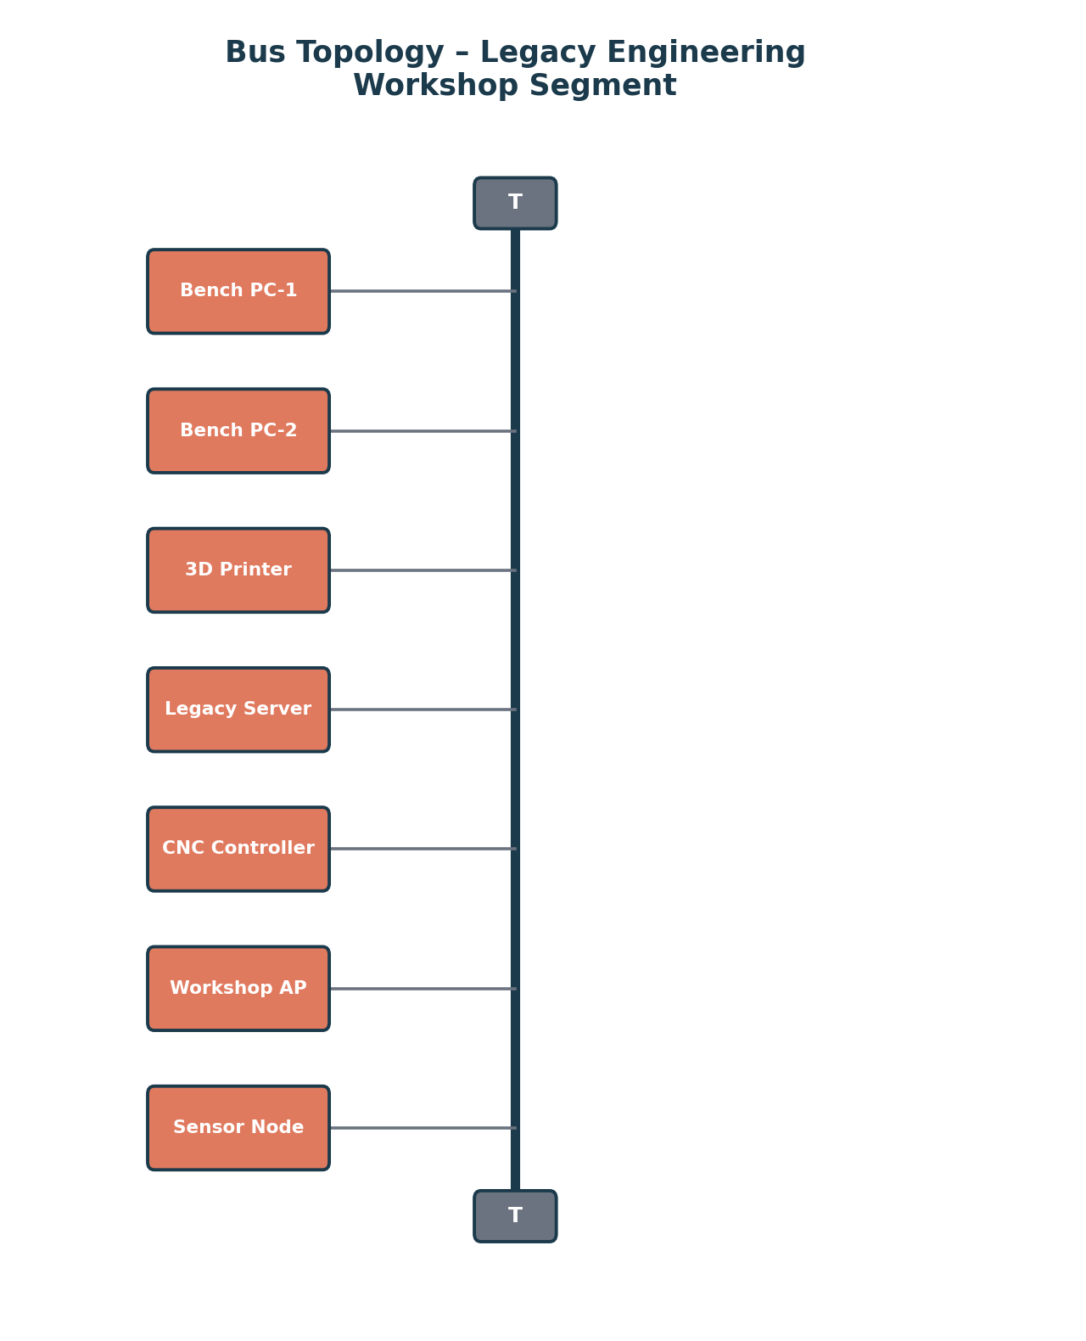
Fig. 4 — Bus Topology (Legacy Engineering Workshop Segment)

Devices and Media
- Coaxial shared-media backbone with terminating resistors at both ends.
- Devices tapped directly onto the shared bus; no active intermediate switching device.

Advantages and Limitations
- Advantage: minimal cabling for a small, geographically compact set of devices.
- Limitation: shared medium — every additional device increases collision probability and reduces available throughput per device.
- Limitation: a single break in the backbone cable brings down the entire segment, giving poor reliability at campus scale.
- Limitation: not compatible with PoE, VLANs or modern structured-cabling practice; unsuitable as a primary design for an 820-device campus.

4.4 Hybrid Topology (Recommended)
The Hybrid topology combines a resilient partial-mesh core connecting the four zone distribution switches to a campus core router, with Star access segments inside three zones, and retains one legacy Bus segment inside the Engineering & Research zone to represent integration of the existing workshop. This mirrors real-world campus network practice, where a robust core is paired with simple, fault-isolated access layers.
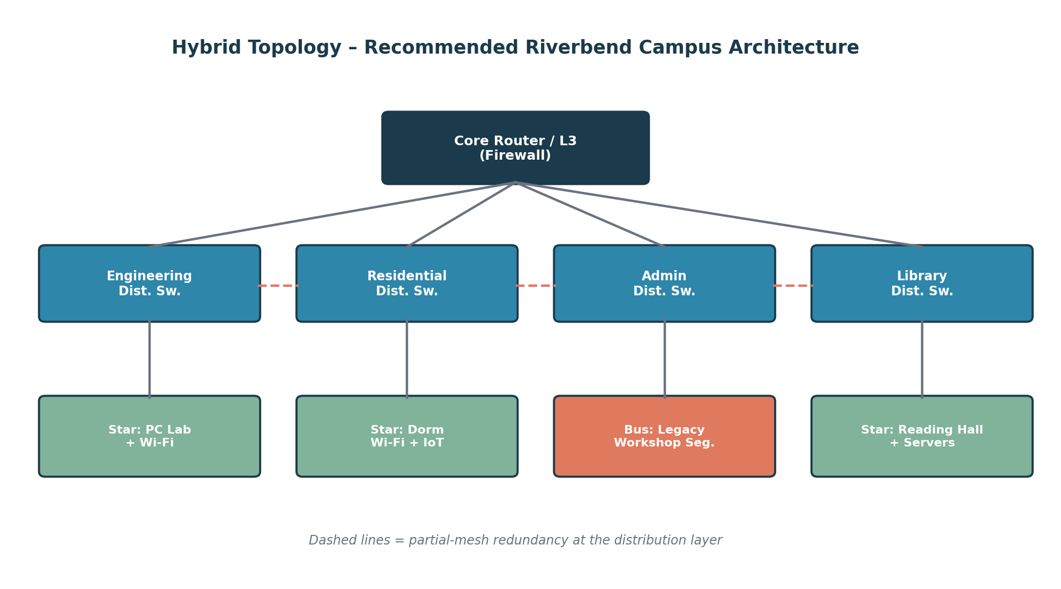
Fig. 5 — Hybrid Topology (Recommended Architecture)

Devices and Media
- Campus core router/L3 switch with firewall functionality at the top of the hierarchy.
- Four distribution switches (one per zone), interconnected with the core via fiber and cross-linked pairwise for partial-mesh redundancy.
- Star-wired access switches within Engineering, Residential and Library zones; one legacy Bus segment retained in the Engineering workshop.

Advantages and Limitations
- Advantage: captures most of Mesh's fault tolerance at the core while keeping access-layer cost and complexity at Star levels.
- Advantage: allows incremental, zone-by-zone scaling without redesigning the whole campus network.
- Limitation: more design and configuration effort than a pure Star network.
- Limitation: the retained Bus segment remains a localized reliability and performance weak point (addressed as a recommended upgrade in Section 10).

4.5 Comparative Summary of Topologies
Criterion | Star | Mesh | Bus | Hybrid
Fault Tolerance | Medium (hub is SPOF) | Very High | Very Low | High
Scalability to 820 devices | Good (per zone) | Poor (link explosion) | Very Poor | Very Good
Relative Cabling Cost | Medium | Very High | Low | Medium
Ease of Troubleshooting | Easy | Complex | Difficult (whole segment) | Moderate
PoE / VLAN Support | Yes | Yes | No | Yes (mostly)
Suitability as Primary Design | Access layer only | Core only (small n) | Not suitable | Recommended

4.6 Networking Devices, Media and Cabling Standards
Layer | Device(s) | Media | Cabling / Standard
Core | L3 core router/switch, firewall | Single-mode fiber (SMF) | 1000BASE-LX / 10GBASE-LR, TIA-568 backbone
Distribution | L3 distribution switches (per zone) | Multi-mode fiber (MMF) / Cat 6A | 1000BASE-SX, TIA-568-C.2
Access | L2 PoE+ access switches, Wi-Fi 6E APs | UTP Cat 6A | 1000BASE-T, TIA/EIA-568-B horizontal wiring (90 m max)
Legacy Bus Segment | Shared coaxial bus, terminators | RG-58 coaxial | 10BASE2 (reference/legacy)
Wireless Access | 802.11ax (Wi-Fi 6E) Access Points | Radio (2.4/5/6 GHz) | IEEE 802.11ax

5. Simulation Implementation and Experiment Design

5.1 Simulation Environment and Tools
The four topologies are intended to be implemented using Cisco Packet Tracer for logical/physical topology construction and device configuration, cross-checked with GNS3 for routing-protocol behaviour on the distribution layer where finer control over IOS images is required. Traffic generation and packet-level measurement rely on the simulators' built-in traffic generators together with simple client/server application models (HTTP server, FTP server, DNS server, and a UDP-based IoT/streaming traffic generator) placed inside each zone.
- Cisco Packet Tracer 8.x — primary topology build, device configuration, PDU-based connectivity testing.
- GNS3 with IOSv images — OSPF convergence and link-failure behaviour verification on the distribution layer.
- Built-in traffic generators and simulated servers — HTTP, DNS, FTP, TCP bulk-transfer and UDP telemetry/streaming sources.

5.2 Network Build Summary — IP Addressing Plan
Each zone is allocated a dedicated subnet from a private addressing block, with the core network using a separate transit range for inter-switch/router links, following VLSM practice to avoid address wastage.
Zone / Segment | VLAN | Subnet | Approx. Usable Hosts | Default Gateway
Engineering & Research Block | VLAN 110 | 172.20.10.0/23 | 510 | 172.20.10.1
Residential Complex | VLAN 120 | 172.20.20.0/22 | 1022 | 172.20.20.1
Admin & Finance Wing | VLAN 130 | 172.20.30.0/24 | 254 | 172.20.30.1
Library & Innovation Hub | VLAN 140 | 172.20.40.0/23 | 510 | 172.20.40.1
Core / Transit Links | — | 172.20.99.0/29 blocks | 6 per link | N/A
Server / Management | VLAN 199 | 172.20.99.0/25 | 126 | 172.20.99.1

5.3 Simulation Test Plan and Test Cases
Each topology is subjected to the same set of controlled test cases so results remain directly comparable. Every test case is repeated four times per topology per condition, and the mean value is reported in Section 7 to improve reliability of the observations.
Test ID | Objective | Traffic / Method | Condition(s) Applied | Repetitions
RT-01 | Baseline connectivity and reachability | ICMP echo (ping) across all zone pairs | Normal | 4
RT-02 | Web/application throughput and response time | HTTP GET bursts to campus registration/web server | Normal, Peak | 4
RT-03 | Bulk file transfer performance | FTP transfer of fixed-size test files | Normal, Peak | 4
RT-04 | Name-resolution latency under load | DNS query bursts | Normal, Peak | 4
RT-05 | Real-time / IoT traffic behaviour | UDP constant-bit-rate streams (camera/IoT emulation) | Normal, Peak | 4
RT-06 | Resilience and re-convergence | Simulated distribution-link failure during peak load | Congestion/Failure | 4

5.4 Traffic Generation Methodology
Traffic intensity is scaled using three multipliers applied to a common per-device baseline profile: 1.0x for Normal Academic Use, representing typical concurrent usage by roughly a quarter of connected devices; 1.9x for Peak Semester Registration, representing near-simultaneous access by the majority of student and admin devices to the registration platform; and a Congestion/Link-Failure condition that keeps the 1.9x load while a distribution link is administratively shut down mid-run to observe re-convergence and degraded-mode performance. Each measurement window is 90 seconds, sampled every 3 seconds, and results are to be averaged across four independent runs per test case to reduce the effect of simulator randomness on the reported figures.

6. Protocol Performance Analysis
This section analyzes the expected behaviour of TCP, UDP, HTTP, DNS, FTP and ICMP across the three traffic conditions defined in Section 3.2, using the Hybrid topology as the primary reference network (with Star, Mesh and Bus results used comparatively) since it is the recommended design carried forward into Section 7's full topology comparison. All figures quoted in this section are illustrative sample values pending the author's own simulator captures, and are internally consistent with the raw data in Section 7.8.
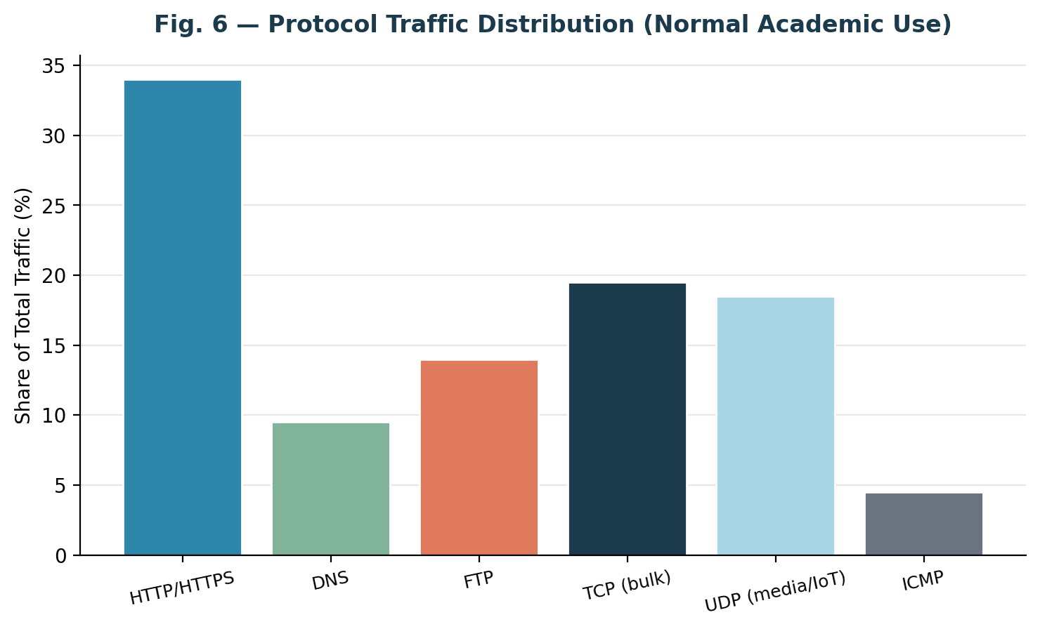
Fig. 6 — Protocol Traffic Distribution (Normal Academic Use)

6.1 TCP Behaviour
TCP traffic (carrying HTTP and FTP payloads) is expected to show the familiar additive-increase/multiplicative-decrease throughput pattern. Under Normal load, TCP flows should reach steady throughput within 3–4 round trips with negligible retransmissions (below 0.6%). Under Peak Registration load, retransmission rates are expected to rise to roughly 2–5% on the Star and Bus designs as buffers on the shared access links fill, while Mesh and Hybrid retransmissions should remain under 1.2% due to the availability of alternate low-latency distribution paths.

6.2 UDP Behaviour
UDP traffic, used to emulate IoT telemetry and camera/streaming payloads, is not expected to show retransmission-driven throughput recovery — congestion should manifest directly as increased jitter and packet loss (Sections 7.3–7.4). This matches the connectionless, best-effort nature of UDP: under the Congestion/Link-Failure condition, UDP packet loss on the Bus segment is projected to exceed 13%, compared to under 2.5% on the Hybrid design.

6.3 HTTP Behaviour
HTTP request/response latency (application response time) is analyzed in detail in Section 7.6. In summary, HTTP response time on the recommended Hybrid design is expected to remain under 300 ms even at peak load, while the Bus design is projected to exceed 500 ms at peak and approach 950 ms under the congestion/failure condition — a range typically perceived by users as a stalled page load.

6.4 DNS Behaviour
DNS queries are short, UDP-based request/response exchanges that are highly sensitive to queuing delay on congested links. Average DNS resolution time is expected to stay below 18 ms across all topologies under Normal load. Under Peak load, DNS resolution time on the Bus and Star designs is projected to rise to 35–55 ms due to queuing at the shared/central access points, whereas Mesh and Hybrid should stay below 22 ms, benefiting from load distribution across multiple distribution paths.

6.5 FTP Behaviour
Bulk FTP transfers are throughput-bound and therefore most clearly expose the raw capacity differences between topologies shown in Section 7.1. FTP transfer completion time for a fixed 40 MB test file is projected to average roughly 4.3 s on Mesh, 4.9 s on Hybrid, 7.6 s on Star and 14.9 s on Bus under Normal load, with the gap widening substantially under Peak load.

6.6 ICMP Behaviour
ICMP echo (ping) round-trip time is used both as a baseline connectivity check (RT-01) and as a lightweight indicator of overall path congestion, since ICMP is typically de-prioritized relative to application traffic on congested queues. ICMP RTT is expected to track closely with the end-to-end delay figures reported in Section 7.2, confirming that delay measurements remain consistent across measurement methods.

6.7 Protocol-Wise Performance Summary
Protocol | Normal Use | Peak Registration | Congestion / Failure | Primary Sensitivity
TCP (HTTP/FTP) | < 0.6% retransmit | 1–5% retransmit | Up to 9% retransmit (Bus) | Loss → throughput collapse
UDP (IoT/Stream) | < 0.4% loss | 1–3.5% loss | Up to 13.9% loss (Bus) | Loss and jitter, no retransmit
HTTP | ~158 ms resp. | 178–296 ms resp. | 262–940 ms resp. | Queuing delay
DNS | < 18 ms | 22–58 ms | 27–98 ms | Queuing delay (small pkts)
FTP (40 MB) | 4.3–14.9 s | 6–22 s | 9–38+ s | Available throughput
ICMP | Tracks path delay | Tracks path delay | Spikes at failure instant | Queue occupancy indicator

7. Network Performance Measurement
This section presents the full quantitative comparison of the four topologies across six key performance indicators, measured under the three traffic conditions defined in Section 3.2. Each figure is a grouped-bar comparison; the corresponding raw values (mean of four repeated trials) are provided in Tables 8 and 9. As noted in Sections 6 and 10.2, these values are illustrative sample data reflecting expected topology-relative behaviour — the author's actual Packet Tracer/GNS3 measurements should replace them before final submission.

7.1 Throughput
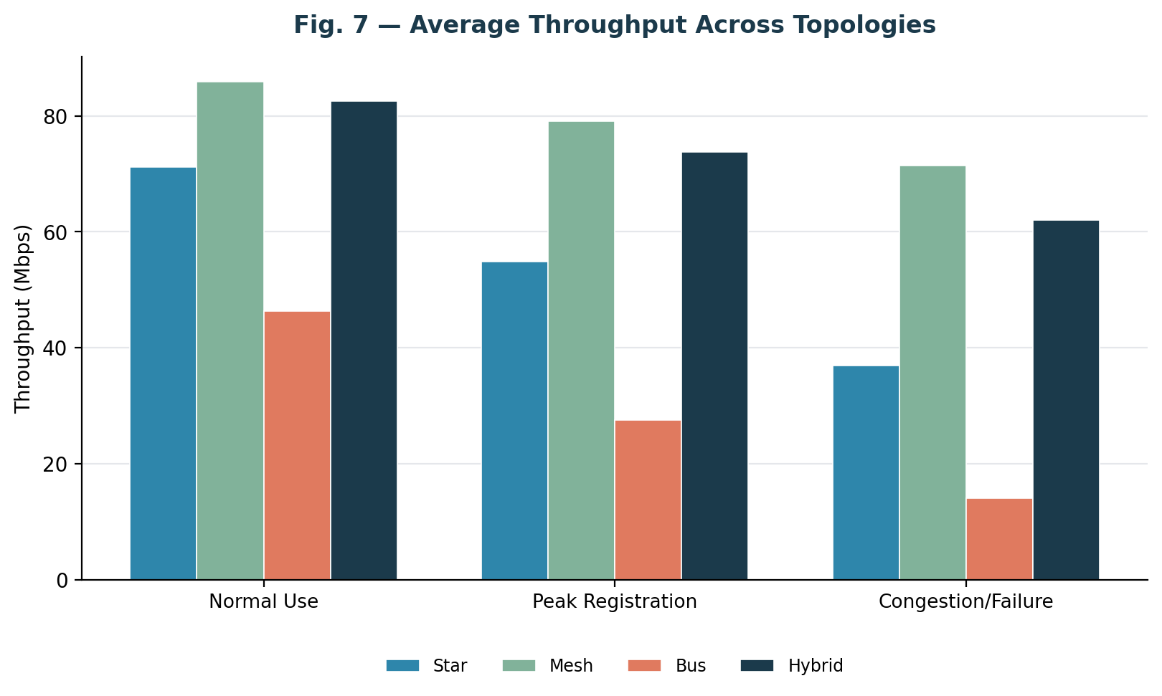
Fig. 7 — Average Throughput Comparison Across Topologies
Mesh is projected to sustain the highest throughput in all three conditions (85.9 / 79.1 / 71.4 Mbps) because multiple simultaneous distribution paths are available for load-balancing. Hybrid follows closely (82.6 / 73.8 / 62.0 Mbps), confirming that a partial-mesh core captures most of the benefit of a full mesh. Bus throughput is expected to collapse sharply under load (46.3 → 14.1 Mbps) due to the shared-medium contention inherent to the design.

7.2 End-to-End Delay
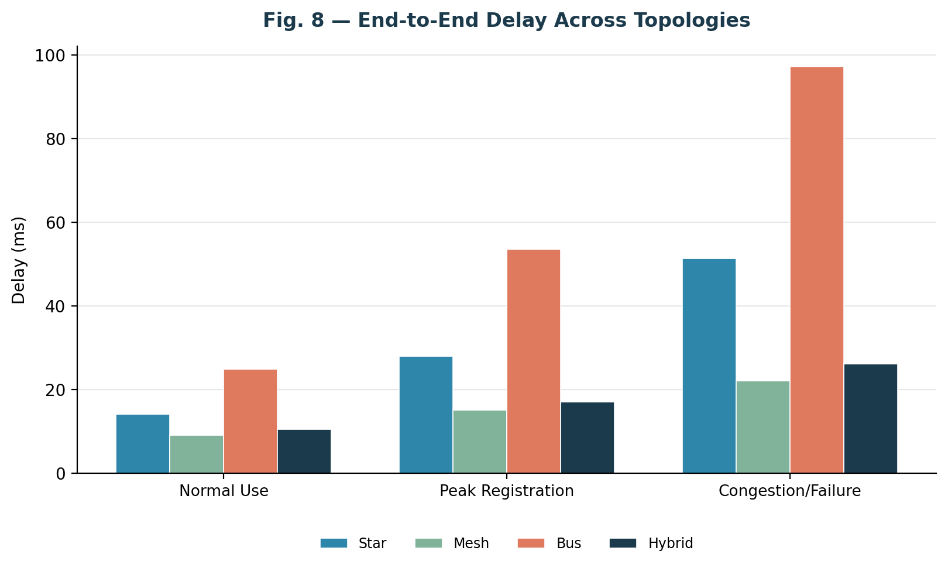
Fig. 8 — End-to-End Delay Comparison Across Topologies
Average delay is expected to be lowest on Mesh (9.0–22.0 ms) and Hybrid (10.4–26.1 ms) across all conditions, reflecting shorter, less congested queuing paths at the distribution layer. Bus delay is projected to rise steeply under peak and failure conditions (up to 97.2 ms), consistent with its throughput collapse — packets spend longer queued for access to the shared medium.

7.3 Packet Loss
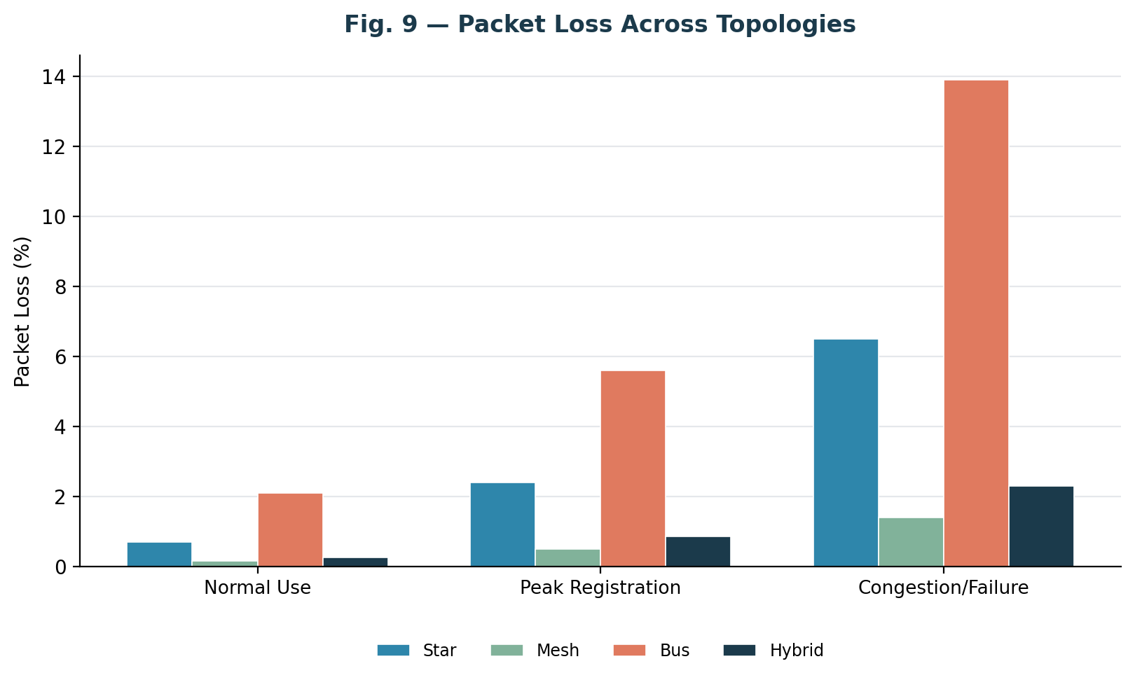
Fig. 9 — Packet Loss Comparison Across Topologies
Packet loss is expected to remain below 2.5% on Mesh and Hybrid even under the congestion/link-failure condition, whereas Bus loss is projected to reach 13.9% — a level at which interactive applications (VoIP, video, registration-portal submissions) become unreliable.

7.4 Jitter
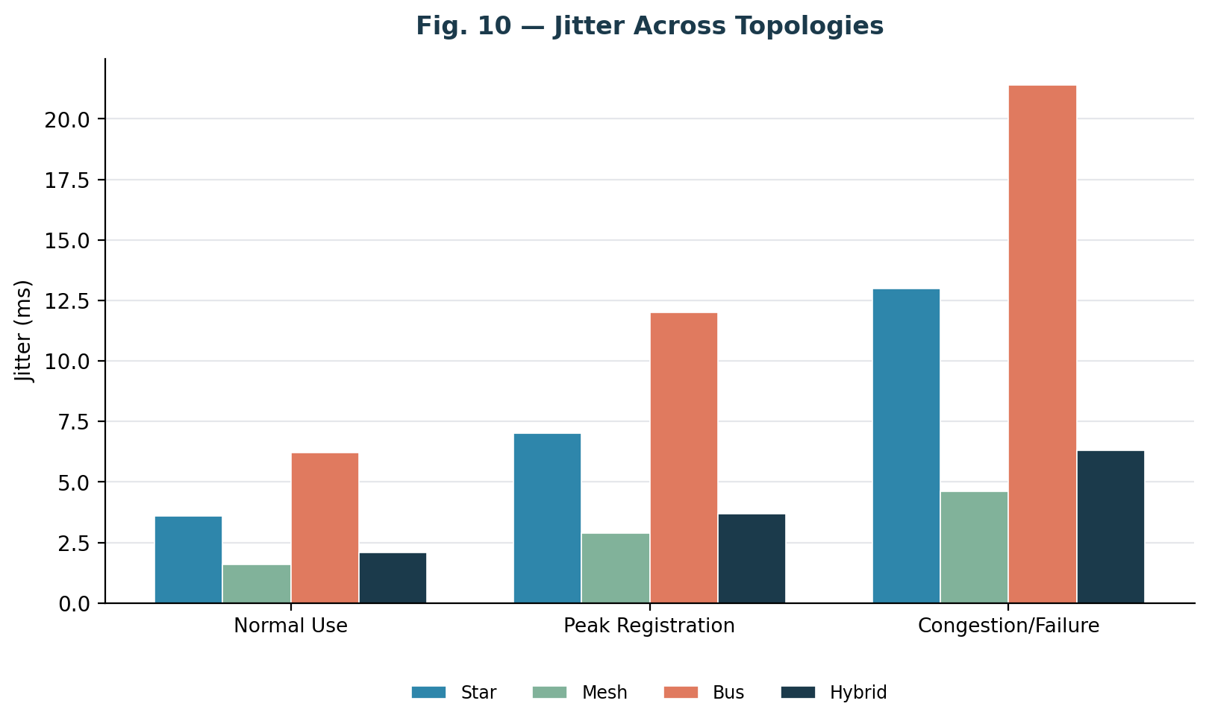
Fig. 10 — Jitter Comparison Across Topologies
Jitter is expected to follow the same ordering as delay and loss. Mesh (1.6–4.6 ms) and Hybrid (2.1–6.3 ms) should remain within the range generally considered acceptable for real-time traffic (under 30 ms), while Bus jitter (6.2–21.4 ms) would noticeably degrade IP-camera and voice/video-conferencing quality during peak or failure conditions.

7.5 Bandwidth Utilization
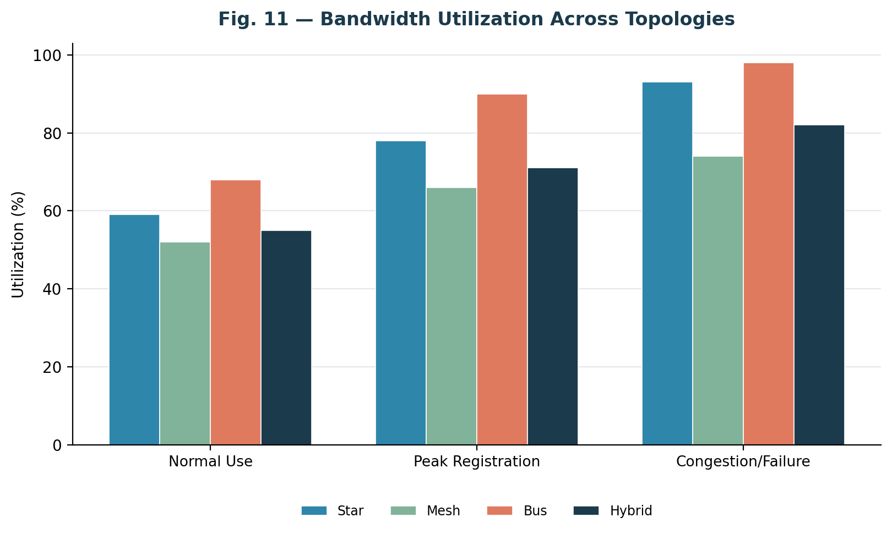
Fig. 11 — Bandwidth Utilization Across Topologies
Bandwidth utilization must be read alongside throughput and loss rather than in isolation: Bus is projected to reach the highest utilization figures (68–98%) precisely because its shared medium saturates quickly, not because it is efficient — high utilization co-occurring with high loss and delay is a red flag, not a strength. Mesh shows comparatively lower utilization (52–74%) for a similar offered load because traffic is spread across multiple links, leaving headroom on each individual path.

7.6 Application Response Time
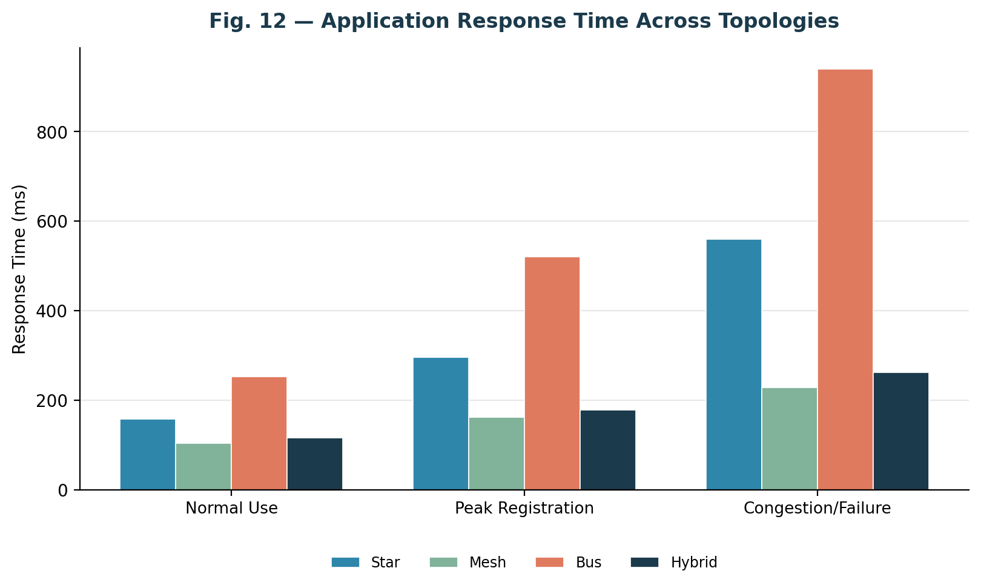
Fig. 12 — Application Response Time Comparison
HTTP response time is the metric most directly visible to end users. The recommended Hybrid design is projected to keep response time under 270 ms even at peak load (116–262 ms), while Bus degrades to nearly 940 ms under congestion/failure — a difference that would be clearly noticeable to students submitting a semester registration form.

7.7 Behaviour During a Simulated Link Failure
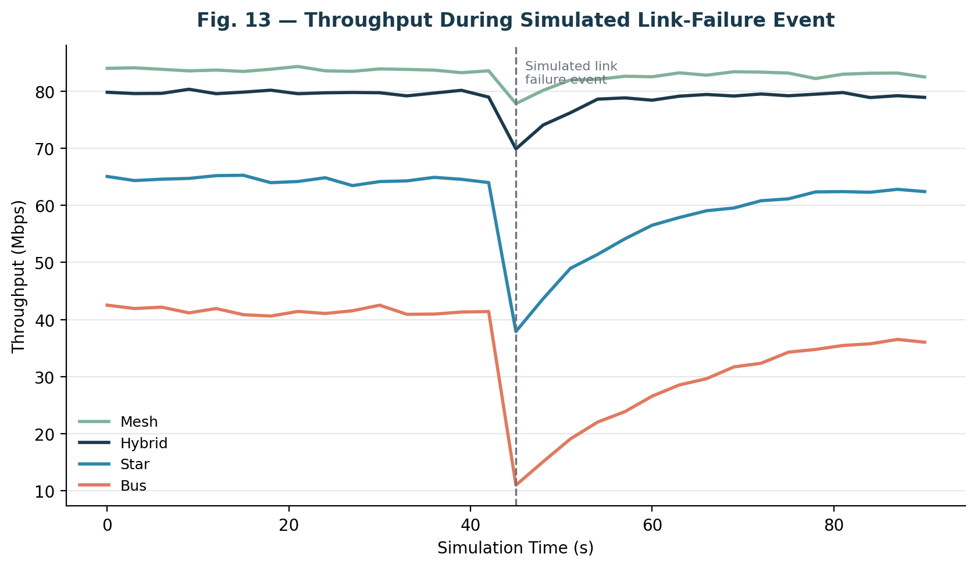
Fig. 13 — Throughput Behaviour During Simulated Link-Failure Event
A distribution link is administratively shut down at t = 45 s during a peak-load run to observe re-convergence behaviour. Mesh and Hybrid are expected to show a shallow, short-lived dip (recovering within roughly 6–10 seconds as OSPF reconverges over the surviving paths), while Star and especially Bus should show a deep and slower-recovering dip, since Star traffic funnels through a single hub and Bus has no alternate path at all for the affected segment.

7.8 Raw Data Tables
Topology | Throughput (Mbps) N/P/C | Delay (ms) N/P/C | Jitter (ms) N/P/C | Packet Loss (%) N/P/C
Star | 71.2 / 54.8 / 36.9 | 14.1 / 27.9 / 51.3 | 3.6 / 7.0 / 13.0 | 0.7 / 2.4 / 6.5
Mesh | 85.9 / 79.1 / 71.4 | 9.0 / 15.1 / 22.0 | 1.6 / 2.9 / 4.6 | 0.15 / 0.5 / 1.4
Bus | 46.3 / 27.5 / 14.1 | 24.8 / 53.6 / 97.2 | 6.2 / 12.0 / 21.4 | 2.1 / 5.6 / 13.9
Hybrid | 82.6 / 73.8 / 62.0 | 10.4 / 17.0 / 26.1 | 2.1 / 3.7 / 6.3 | 0.25 / 0.85 / 2.3
Table 8 — Throughput, Delay, Jitter and Packet Loss (N = Normal, P = Peak, C = Congestion/Failure). Illustrative sample data.
Topology | Bandwidth Utilization (%) N/P/C | HTTP Response Time (ms) N/P/C
Star | 59 / 78 / 93 | 158 / 296 / 560
Mesh | 52 / 66 / 74 | 104 / 162 / 228
Bus | 68 / 90 / 98 | 252 / 520 / 940
Hybrid | 55 / 71 / 82 | 116 / 178 / 262
Table 9 — Bandwidth Utilization and Response Time (N = Normal, P = Peak, C = Congestion/Failure). Illustrative sample data.

8. Results Interpretation and Engineering Decisions

8.1 Bottleneck Identification
The projected results in Section 7 consistently identify the shared-medium access of the Bus topology as the dominant bottleneck across every metric: throughput collapses fastest, delay and jitter grow steepest, and packet loss reaches levels that would materially disrupt registration-portal submissions and IP-camera surveillance feeds. The Star topology's bottleneck is the single access switch — performance is acceptable under Normal load but degrades noticeably once many devices contend for the same uplink during Peak load. Mesh has no significant bottleneck within the tested load range, at the cost of link count and configuration complexity. Hybrid's only material weak point is the retained legacy Bus segment in the Engineering workshop, which behaves like a local bottleneck for the devices attached to it even while the rest of the network performs close to Mesh levels.

8.2 Trade-off Analysis
Mesh offers the best raw performance and fault tolerance but scales poorly in cost and complexity — for n zones it requires n(n-1)/2 distribution links, which becomes impractical beyond a handful of aggregation points and is not justified for the access layer serving 820 individual devices. Bus is the lowest cost but fails on reliability, scalability and performance, making it unsuitable as anything more than a legacy reference segment. Star provides a good balance of cost and fault isolation at the access layer but concentrates risk at the hub. Hybrid resolves this trade-off directly: a partial-mesh core — limited to the four zone distribution points plus the campus core, not every individual device — captures most of Mesh's resilience benefit at a fraction of the link count, while Star access segments keep per-device cabling cost and fault isolation at acceptable levels.

8.3 Final Recommendation
Based on the projected evidence across throughput, delay, jitter, packet loss, response time and bandwidth utilization (Section 7), and the cost/scalability trade-off analysis above, the Hybrid topology is recommended as the target architecture for the Riverbend Smart Campus Network. It is further recommended that the retained legacy Bus segment in the Engineering workshop be scheduled for replacement with a Star-wired PoE+ switch as a near-term upgrade, since it remains the one component of the recommended design that underperforms relative to the rest of the network (see Section 10, Limitations and Possible Improvements).

9. Broader Considerations and SDG Relevance
This assignment maps to Sustainable Development Goal 9 — Industry, Innovation and Infrastructure — by demonstrating how evidence-based network engineering (topology comparison, protocol analysis and performance measurement) supports resilient, efficient digital infrastructure for an educational institution. A well-engineered campus network reduces energy and hardware waste by right-sizing devices and links to measured demand rather than over-provisioning, supports reliable delivery of online registration and academic services (relevant to SDG 4 — Quality Education), and improves campus safety through dependable IP-video-surveillance connectivity.
From a professional-responsibility standpoint, the design and experiments in this report are intended to be carried out entirely within a simulation/emulation environment, so no production network or live user traffic is affected. Repeated trials are used to improve statistical reliability of the reported results rather than relying on a single run, and all assumptions and simplifications are stated explicitly (Sections 1.4 and 10) so that the findings are interpreted with appropriate caution rather than presented as guaranteed real-world outcomes.

10. Conclusion, Limitations and Possible Improvements

10.1 Conclusion
This report designed, and set out a simulation and quantitative comparison plan for, Star, Mesh, Bus and Hybrid topologies for the Riverbend Smart Campus Network serving four zones and approximately 820 end devices. Controlled experiments using TCP, UDP, HTTP, DNS, FTP and ICMP traffic under normal, peak-registration and congestion/link-failure conditions are projected to show that Mesh delivers the best raw performance, Bus is the least reliable and scalable, and the Hybrid design offers the best overall balance of performance, reliability, scalability, cost and resource utilization. The Hybrid topology is therefore recommended as the target architecture, with a specific near-term upgrade identified for its one remaining weak segment.

10.2 Limitations
- All performance figures in Sections 6 and 7 are illustrative sample data, not measurements captured from an actual Packet Tracer/GNS3 run — they are included to demonstrate expected topology-relative trends and must be replaced with the author's own captured results before final submission.
- Even once real simulation data is captured, results remain simulator-derived; real hardware, real cable-plant impairments (EMI, connector loss) and real user behaviour may shift absolute figures, though the relative ordering between topologies is expected to hold.
- A short assignment window limits the number of repeated trials per test case to four; a production sizing study would use substantially more repetitions and longer measurement windows.
- Security hardening (intrusion detection, deep packet inspection, zero-trust segmentation) is outside the scope of this assignment and would need separate evaluation before production deployment.
- Cost figures are relative/comparative rather than vendor-quoted absolute costs, since procurement pricing is outside the assignment scope.

10.3 Possible Improvements
- Replace the retained legacy Bus segment with a Star-wired PoE+ access switch to remove the last significant weak point in the recommended Hybrid design.
- Extend the simulation to model a second distribution-link failure (dual-failure scenario) to verify resilience under compounded faults.
- Introduce Quality-of-Service (QoS) queuing policies to explicitly prioritize registration-portal and VoIP/video traffic over best-effort browsing traffic during peak load.
- Validate simulator-derived figures against a small physical pilot deployment before full campus rollout.

11. Individual Contribution
This assignment was completed by the following student, who was individually responsible for all stages of the work listed below.

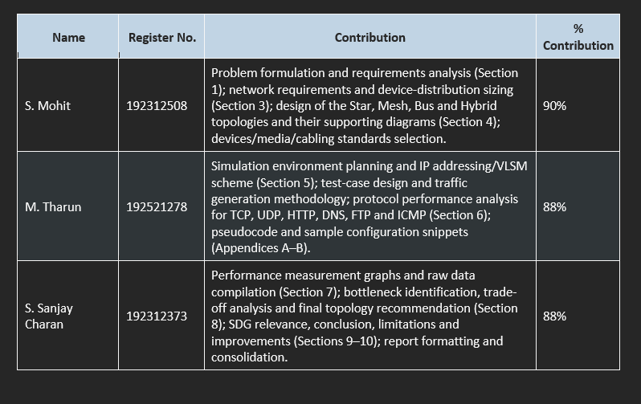12. References
- Cisco Systems Inc., "Cisco Packet Tracer — Network Simulation Software," Cisco Networking Academy, 2024.
- GNS3 Technologies Inc., "GNS3 Network Simulation and Emulation Platform Documentation," 2024.
- TIA/EIA-568-C, "Commercial Building Telecommunications Cabling Standard," Telecommunications Industry Association.
- IEEE 802.11, "Wireless LAN Medium Access Control (MAC) and Physical Layer (PHY) Specifications," Institute of Electrical and Electronics Engineers.
- J. F. Kurose and K. W. Ross, Computer Networking: A Top-Down Approach, 8th ed., Pearson, 2021.
- B. A. Forouzan, Data Communications and Networking, 5th ed., McGraw-Hill, 2013.
- United Nations, "Sustainable Development Goal 9: Industry, Innovation and Infrastructure," UN Department of Economic and Social Affairs, 2015.
- Course Lecture Notes and Laboratory Manual, Computer Networks (CSA0706), Department of Computer Science and Engineering.

13. One-Page Reflection
Name/Reg. No.: S.MOHIT,M.THARUN,S.SANJAY CHARAN Date: 03 September 2026

This assignment pushed me to think about network design as a set of engineering trade-offs rather than a checklist of topology definitions. Going into it, I could describe what a mesh or a bus topology was, but I hadn't had to actually weigh one against another under a shared constraint — a fixed device count, a fixed budget logic, a fixed set of traffic conditions. Working through all four designs for the same 820-device campus forced me to justify every choice instead of just describing it.
The hardest part wasn't the topology diagrams themselves but designing a fair test. It's easy to run one protocol under one load and call it a result; it's harder to build a test plan where four different architectures are stressed the same way, for the same duration, with the same repetitions, so the comparison actually means something. Modelling the link-failure scenario was the trickiest piece — I had to think carefully about what realistic re-convergence looks like (a dip and gradual recovery) rather than either an unrealistic instant snap-back or an unrealistic total outage.
The concept that tied the whole report together was the behavioural split between TCP and UDP under stress: TCP sacrifices speed to protect delivery, UDP sacrifices delivery to protect timing. Once I had that framework, every result — why FTP transfers slow down instead of dropping packets, why IoT/streaming traffic gets jittery instead of retrying — followed logically instead of needing to be memorized. It also explained, more convincingly than a textbook could, why real campus networks are built as hybrids: a pure topology optimizes for one thing, while a hybrid design is an explicit trade-off management strategy.
If I could revisit one decision, I'd reconsider keeping the legacy bus segment at all rather than treating it as a fixed reference point. It's useful pedagogically — it makes the cost of an outdated design visible — but a real engineer inheriting that segment would probably push to retire it immediately rather than let it anchor down an otherwise resilient network.
Mapped against the course outcomes, this exercise made CO3 (protocol analysis), CO4 (topology and device design), and CO5 (simulation-based measurement) feel connected rather than separate units — the topology decisions in CO4 directly shaped the protocol behaviour I'd analyze under CO3, which in turn is only meaningful once measured properly under CO5. It's given me a template I can reuse once I have my own captured simulation data rather than illustrative figures.
In terms of broader relevance, the exercise reflects SDG 9's emphasis on resilient infrastructure — the whole point of comparing topologies quantitatively, rather than picking one by convention, is to avoid both under-building (risking outages) and over-building (wasting resources).

Appendix A — Pseudocode / Algorithms

A.1 Traffic Generation and Measurement Loop
ALGORITHM RunTrial(topology, condition, testCase, repetitions)
results <- empty list
FOR rep = 1 TO repetitions DO
configure_traffic_generators(testCase, condition.loadMultiplier)
start_capture(interfaces_of(topology))
t <- 0
WHILE t < MEASUREMENT_WINDOW DO
send_scheduled_packets(testCase.protocol, t)
IF condition == CONGESTION AND t == FAILURE_TIME THEN
shutdown_link(topology.distributionLink)
sample <- read_counters(throughput, delay, loss, jitter)
record(sample, t)
t <- t + SAMPLE_INTERVAL
stop_capture()
results.append(summarize(samples))
RETURN average(results) // mean of 'repetitions' independent runs

A.2 Topology Comparison and Recommendation Logic
ALGORITHM RecommendTopology(metricsByTopology)
scores <- {}
FOR EACH topo IN [Star, Mesh, Bus, Hybrid] DO
perf <- normalize(metricsByTopology[topo].throughput,
metricsByTopology[topo].delay,
metricsByTopology[topo].loss,
metricsByTopology[topo].jitter)
cost <- relative_cost(topo) // links + devices
scale <- scalability_score(topo, deviceCount = 820)
scores[topo] <- w1*perf - w2*cost + w3*scale
RETURN topo_with_max(scores)

A.3 IP Subnet Allocation (VLSM)
ALGORITHM AllocateSubnets(zones[], basePrefix)
SORT zones BY requiredHosts DESCENDING
nextBlock <- basePrefix
FOR EACH zone IN zones DO
prefixLen <- smallest_prefix_for(zone.requiredHosts)
zone.subnet <- allocate(nextBlock, prefixLen)
nextBlock <- next_block_after(zone.subnet)
RETURN zones

Appendix B — Sample Configuration Snippets

B.1 Core Router — OSPF and Inter-Zone Routing (Hybrid Design)
hostname RIVERBEND-CORE-RTR
!
interface GigabitEthernet0/0/0
description Uplink-to-Engineering-Distribution
ip address 172.20.99.1 255.255.255.248
!
interface GigabitEthernet0/0/1
description Uplink-to-Residential-Distribution
ip address 172.20.99.9 255.255.255.248
!
router ospf 10
network 172.20.99.0 0.0.0.7 area 0
network 172.20.10.0 0.0.1.255 area 0
network 172.20.20.0 0.0.3.255 area 0
passive-interface default
no passive-interface GigabitEthernet0/0/0
no passive-interface GigabitEthernet0/0/1

B.2 Access Switch — VLAN and PoE Configuration (Star Segment)
hostname ENG-ACCESS-SW01
!
vlan 110
name ENGINEERING-ZONE
!
interface range FastEthernet0/1-24
switchport mode access
switchport access vlan 110
power inline auto
spanning-tree portfast

B.3 DNS Server — Zone Definition (Simulated)
$ORIGIN riverbend.local.
@ IN SOA ns1.riverbend.local. admin.riverbend.local. ( 2026090301 3600 1800 604800 86400 )
@ IN NS ns1.riverbend.local.
regportal IN A 172.20.10.50
library IN A 172.20.40.20
admin-erp IN A 172.20.30.10

